Nottingham Trent University

School of Science and Technology

Healthify

by

Hamid Mujatab

in

2020

Project report in part fulfilment

of the requirements for the degree of

Bachelor of Science with Honours

in

Software Engineering

I hereby declare that I am the sole author of this report. I authorize the Nottingham Trent University to lend this report to other institutions or individuals for the purpose of scholarly research.

I also authorize the Nottingham Trent University to reproduce this report by photocopying or by other means, in total or in part, at the request of other institutions or individuals for the purpose of scholarly research.

Hamid Mujtaba

Abstract

Enter abstract here. The abstract should include: A) Brief statement of problem B) Brief exposition of methods and procedures and C) Brief summary of findings.

After the title, the abstract is the next level of detail regarding your work. The scientific community relies on 'The Abstract' as the main means of communicating research interests. There are many collections of abstracts published from which interested parties can trace the original work. They form the first step in a researcher's quest for up to date information regarding work being carried out worldwide.

The abstract is a one A4 page, 1.5 Line Spacing, retrospective account of the achievements, techniques and conclusions of the report. On no account are you to exceed one page. Do not go into a great long explanation of the general area, be very precise and stick to what you have achieved. This is filed by the library and enquirers from other institutions are sent a photocopy of this single sheet and thus immediately assess the work's relevance to them. They will know about the general subject area and its problems; what they want to know is whether you have found a solution. Be sure to include as much relevant information as possible on that page.

The abstract is very much an impersonal, factual, retrospective account of your finished project as might be written by somebody else. The tone of the English might be 'The work introduces the general area of..... and then investigates an apparently new method for..... The method is partially successful in that it...... '.

Acknowledgements

Enter acknowledgements here. It is usual to acknowledge those that have assisted you in your work and will normally include your main project supervisor. The order of acknowledgments (most important first) and their respective length indicates their relative importance to you.

Table of Contents

Abstract ii

Acknowledgements iii

Table of Contents iv

List of Figures vii

List of Tables viii

CHAPTER 1 1

Introduction 1

1.1 Introduction 1

1.2 Aims and Objectives 2

CHAPTER 2 4

CONTEXT 4

2.1 Introduction 4

2.2 Literature Review 4

2.2.1 Health Risks Associated with Obesity 7

2.2.2 Solution to Obesity Epidemic and Benefits of Exercise 8

2.2.3 Health and Technology 10

2.3 Current Solutions 10

2.3.1 Exergames 11

2.3.2 Wearable Technology 12

2.3.3 Active Notts (Website) 13

2.3.4 Smartphone Applications 14

2.3.5 Comparison 21

CHAPTER 3 28

New Ideas 28

3.1 Introduction 28

3.2 Proposed Solution 28

3.2.1 Application Features 28

3.2.2 Track Progress 30

IMPLEMENTATION or INVESTIGATION 31

3.3 Introduction 31

CHAPTER 4 33

RESULTS / DISCUSSION 33

4.1 Introduction 33

CHAPTER 5 34

CONCLUSIONS / FUTURE WORK 34

5.1 Conclusions 34

5.2 Future work 34

5.3 Legal, Social, Ethical and Professional Issues 34

5.4 Synoptic Reflections 34

ReferenceS 35

Bibliography 36

Appendix A 39

List of Figures

Figure 1: Adults Effected by Obesity 5

Figure 2: Rate of Obesity Over the Years 5

Figure 3: Kids in Reception Effected by Obesity 6

Figure 4: Kids in Year 6 Effected by Obesity 7

Figure 5: Register Screen 29

Figure 6: Login Screen 29

Figure 8: BMI Test 30

Figure 7: 'User Targets' Screen 30

List of Tables

Table 1: Microsoft Office. 5



Introduction

Introduction

The focus of this project is to promote a healthier lifestyle through a smartphone application by encouraging individuals to exercise more and help to implement healthy habits in their lives.

Over the years, technology has greatly improved and made lives easier. Technology is being used in nearly every sector, from construction to medicine, and by every kid, teenager, and adult in their daily lives. However, technology has a lot of negative impacts associated with it; excessive use of technology is making people lazy, making them less active and affecting their well-being. For this reason, technology is known to be pervasive, however in the past few years, innovative ways of using technology to benefit people’s well-being have been sought. The lack of exercise in our society has led to an increase in a lot of health-related diseases/illnesses such as heart disease and obesity, as well as playing a big role in other medical conditions. As a result of this, there are now countless smartphone applications and many fitness equipment (i.e. smartwatches) made available to people in the hopes of helping them stay healthy and improve their overall well-being.

Unfortunately, even with this growing innovation of resources and research being conducted to find more efficient ways to improve our health, statistics (refer to Figure 2) show that obesity is still increasing over the past couple of years instead of decreasing. This suggests that, although there are now advanced technical resources in place to benefit people, these are mostly used by those who already engage in physical activity. Through my research, I have found that the general populace do not interact with or use these resources. I speculate that the main reason for this is how the average person would not know how or where to start getting into exercising, as they lack the relevant information regarding a healthier lifestyle. Another reason could be lack of motivation, which can also be linked with the first reason; as they do not have all the information available to them, they will therefore struggle to find motivation. This results in many people giving up on trying to achieve a healthier lifestyle after only minimal browsing.

Aims and Objectives

This project aims to develop a smartphone application which will encourage and help motivate individuals live a healthier lifestyle. It will contain all the necessary information they will need to improve their well-being such as; different physical exercise, indoors and outdoors; how to manage weight; managing calories intake and other beneficial healthy habits. It will focus on different ways to keep the users motivated and engaged over time, helping them reach their goal of living a healthier lifestyle. The project will take inspiration from popular fitness applications and will look to improve on the features already available by developing a solution which will aim to focus on the areas they are lacking in.

The roadmap to the rest of this document, Chapter 2: Context will analyse existing research and solutions promoting healthier lifestyle. It will also identify the limitations of the current solutions and how to overcome them. The following chapter, Chapter 3: New Ideas will propose a new solution, taking the research done in the previous chapter into consideration, by building on and improving on strong features identified in chapter 2. Chapter 4: Implementation documents the process of the designing and implementation of the proposed solution. Once the proposed solution has been implemented, Chapter 5: Results/Discussion will analyse and discuss the results of testing and evaluation carried out on the implemented solution. The final chapter, Chapter 6: Conclusions/Future Work reflects on what has been learned and summarise the success of the project, in addition to briefly discussing any potential improvements and/or future work.



CONTEXT

Introduction

this chapter will present and discuss the research done on the topic and existing solutions promoting healthier lifestyles. The literature is then analysed and examined further to identify limitation of the current solutions.

Literature Review

The project will tackle physical health issues in the UK due to lack of exercise. According to the research done by NHS (July 2012), a lot of health issues in the UK are due to the lack of exercise which is “as deadly as smoking”. It has been estimated that “one in 10 cases of heart disease (10.5%) and just under one in five cases (18.7%) of colon cancer in the UK” often can be due to lack of exercise. In 2008, inactivity caused more than 5.3 million of the 57 million deaths estimated worldwide (NHS 2012). Lack of exercise can also cause the bones to become weak, risk of diabetes or hypertension (Kristin Davis, n.d). However, over the years, health issues relating to lack of exercise didn’t decrease; obesity being one of the main concerns. Obesity is a medical condition where a person is overweight and carries unhealthy amount of body fat which influences their health. In a very recent article by NHS (May 2019), during 2017/18, there were 10,660 patient admissions who had illnesses directly relating to obesity and 711,000 where obesity was “primary or a secondary diagnosis”; which is very similar to the statistic recorded in 2016/17 (10,705). Obesity was more common in female adults than it was in male adults. For every 4 patients, 3 were female (74%) for illnesses directly relating to obesity, and around 2 in every 3 (66%) for illnesses that had some relation to obesity. The 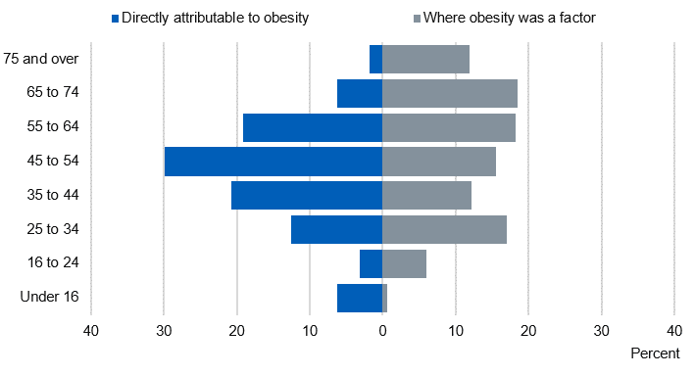statistics show that obesity was commonly found in adults aged between 35-64.

Figure : Adults Effected by Obesity

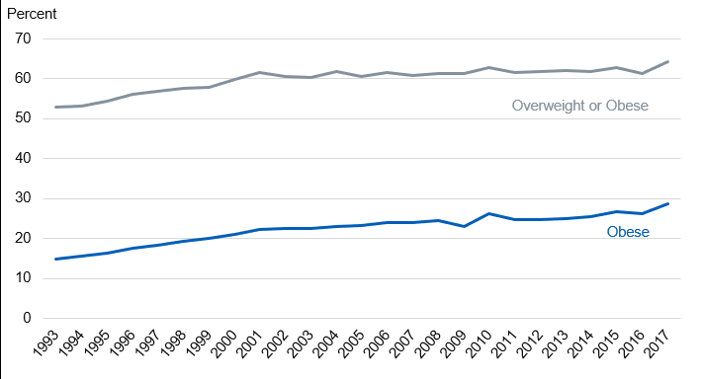“The majority of adults in England in 2017 were overweight or obese (64%)” and the percentage of obese adults was “29% higher than in recent years” (NHS 2019). The percentage of obesity increased “steeply between 1993 and around 2000” in England, however, the rate of increase became slower after that.

Figure : Rate of Obesity Over the Years

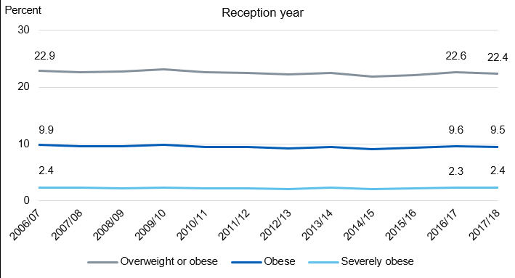This suggests that despite NHS knowing the increase of obesity throughout UK for a very long time, and researchers having come up with solutions to tackle this issue, they could not decrease the amounts of patients being admitted into hospitals due to obesity; instead, the numbers were gradually increasing with time – nonetheless, they did manage to slow it down in recent years. The research showed that not only adults are at risk of being diagnosed with physical health illnesses such as obesity, but young children too. The same article stated that in 2017/18 prevalence of obesity in year 6 children has increased by 1% compared to 20.0% in 2016/17 (Fig.4). For children in reception the percentage did not change much and was “similar at 9.5% in 2017/18” (Fig.3). However, compared to 2006/07 the percentage is lower for children in reception but is higher for kids in year 6 (NHS 2019).

Figure : Kids in Reception Effected by Obesity

Figure : Kids in Year 6 Effected by Obesity

### Health Risks Associated with Obesity

If someone is even 40% overweight, they are “twice as likely to die prematurely” compared to an average weight person (Robert 2017). This this because obesity is a serious health hazard has a high chance of leading to other health problems. Some of the serious health conditions include; heart disease and stroke, high blood pressure, diabetes, cancer, gallbladder and gallstones, breathing problems such as asthma and apnoea just to mention a few. Heart disease and stroke are known to be the leading causes of death/disability according to research done in the U.S (Robert 2017). Being overweight can increase the risks of high blood levels of cholesterol which often leads to heart disease. It can also lead to angina (pain in the chest caused by decreased oxygen to the heart) and sudden death. Type 2 diabetes is one of the two major types of diabetes which is a major cause of early death as well as heart disease, stroke, and blindness, which reduces the body’s ability to control blood sugar. Being overweight can increase the risk of getting type 2 diabetes by two times. Gallstones are small stones in the gallbladder. In most cases, they do not need to be treated, however, if it becomes trapped in an opening inside gallbladder, it can cause intense pain in the tummy. Gallstones are very common in the UK as it is estimated that “more than 1 in every 10 adults in the UK has gallstones” (NHS 2018). Research shows that the individuals who are likely to develop gallstones are overweight/obese, a female or 40 (and over). According to cancer research UK (2018) “more than 1 in 20 cancer cases are caused by excess weight” in the UK and being overweight/obesity is the second most preventable cause of cancer. There are many types of cancer which is caused by excess weight such as breast cancer (in women), bowel, womb, kidney, liver, meningioma (type of brain tumour) etc. Men are more likely to develop colorectal cancer and prostate cancer. This includes breast and bowel cancers which are the most common types of cancer, and pancreatic, oesophageal and gallbladder cancers, which are the most difficult to treat (Cancer Research UK, 2018). Increasing the amounts of physical activity can help reduce weight, which in turn will decrease the chances of developing the diseases mentioned.

### Solution to Obesity Epidemic and Benefits of Exercise

There is no simple solution or strategies to prevent diseases such as obesity. It’s a very complicated problem therefore a multifaceted approached must be taken. Contrary to what some people think, key to “maintaining a healthy weight isn’t short-term dietary chances changes; its about a lifestyle that includes healthy eating and regular physical activity” (Centers for Disease Control & Prevention, 2019). Patients of such diseases are also advised to lose “weight safely by eating a healthy, balanced diet and regular physical activity” by their GPs (NHS, 2019). To lose weight at a safe and healthy rate, people are advised to reduce their calories intake by 600 per day. The exact amount will vary between men and women. For men, they are recommended to consume 1,900 calories maximum a day, and 1,400 calories (a day) for women. A healthy diet should include lots of fruit and vegetables, plenty of starchy foods (such as bread, rice, pasta etc), milk/dairy foods, non-dairy sources of protein (such as fish, meat, eggs etc), and small amounts of food/drinks which contain high fat and sugar. It is important not to consume foods which contain high levels of salt as they can raise blood pressure, which can be dangerous if you are already obese. However, it is advised to avoid fad diets as they are unsafe and could make you ill. Managing your calories intake will help you lose weight, however maintaining that healthy weight will require you to do some physical activity to burn energy. According to NHS (June 2018), exercise “can reduce your risk of major illnesses, such as heart disease, stroke, type 2 diabetes and cancer by up to 50% and lower your risk of early death by up to 30%”. Physical activity isn’t only beneficial for those who wish to maintain healthy weight, but “it can help prevent and manage more than 20 conditions, such as reducing the risk of type 2 diabetes by 40%” (NHS, 2019). It is recommended by the Chief Medical Officers for an adult to do minimum of 150 minutes of activity a week (moderate intensity). Brisk walking, cycling, and dancing are all examples of moderate-intensity activity, where the activity increases your heart rate. Alternatively, to push yourself further, you could do 75 minutes of vigorous-intensity activity every week, where your heart beats very fast and breathing gets hard. Examples of vigorous activity include, running, jumping rope, most competitive sports or hiking uphill etc. To prevent obesity, it is recommended to exercise longer each day or regaining weight. 45-60 minutes of moderate-intensity activity a day is recommended to prevent obesity, and 60-90 minutes of activity each day to avoid regaining weight. Parents are advised by GPS that “children over the age of 5 should ideally get at least 60 minutes of vigorous-intensity exercise a day” and idle activities such as playing games or watching TV should be restricted (NHS, 2019). According to research, it is medically proven that people who do regular exercise have up to a 35% lower risk of coronary heart disease and stroke, 50% lower risk of type 2 diabetes, 50% lower risk of colon cancer, 20% lower risk of breast cancer, 30% lower risk of early death, 83% lower risk of osteoarthritis, 68% lower risk of hip fracture, 30% lower risk of falls (among older adults), 30% lower risk of depression and 30% lower risk of dementia (NHS, 2018).

### Health and Technology

People have become less active in the modern age, partly due to technology as it has made our lives easier. On the other hand, technology has also been benefiting us as it has played a big part in improving healthcare and revolutionised the way we exercise. Some of the benefits technology has brought to healthcare include better treatments and equipment which enabled doctors to provide better care and help treat long-term illnesses, improving the quality of life of many people. Better equipment has also allowed doctors to research medicine more efficiently which has helped find treatments for some life-threating illnesses. It has made it easier for physicians around to world to share their finding and information of their research; patient records are stored into cloud database which the doctors can access any time to view in-depth medical information of the patient. Technology has made it a lot easier to identify diseases and help with disease control with the use of new, advanced software. This has allowed “World Health Organization [WHO] to classify some illnesses, their causes, and symptoms into a massive database that has more than 14,000 individual codes” (Awais dar, 2018). This data can then be accessed by medical professionals and researchers which allows them to control disease and improve healthcare.

## Current Solutions

Technology is also playing an active role in promoting exercise in the form of exergames, wearable technology and mobile applications. Exergames was mostly targeted at children and teenagers as they were known to spend majority of their free time playing games instead of going out, but now it also attracts adults as there are a variety of games targeting them. However, exergaming is not the cure for inactive lifestyle, but is a mean to motivate people who do not to do any form of physical activity, to exercise. The engaging nature of the game makes it enjoyable for everyone which is perfect for people who struggles to do any exercise because with other forms of exercise, they would think how tired and exhausted they are, but with exergames, their mind will be occupied in the game and how much fun they are having. Exergames can help you burn as many calories (or more) as brisk walking and can be beneficial to people who have been diagnosed with type 2 diabetes or obesity. These games also allow interaction between other players where you can play together with you family or friends which further helps motivate the person.

### Exergames

Dance Dance Revolution (DDR) is a very popular and one of the best examples of exergames. It is a perfect alternative to outdoor physical activities such as running, cycling, and swimming. DDR is available on the console and can be played using a dance pad/mat. It also has a workout mode where the user can choose from workout time or calorie burn mode. Workout time allows you to have a session which can last up to two and a half hours. There are different difficulty modes the user can choose from, beginner mode, intermediate, and advanced. The calorie burn mode allows the user to pick the number of calories they would like to burn during that session. It’s recommended to select somewhere in between 300-750 calories. During each stage in the game, it will display how many calories the user has burned (or the session time remaining) and will also display the equivalent of how much you have run. Wii Sports in another great example of exergame which was produced by Nintendo for their console, Nintendo Wii. It included five different games, tennis, golf, bowling, boxing, and baseball, which can be played using a wireless, handheld controller which detects the players movement and mimics them. For example, for the baseball game, the user will need to swing their control and time it correctly to produce the swing of the bat on the screen. Although Wii Sports will not help players burn as many calories as playing an actual sport, it can help them keep fit.

### Wearable Technology

Wearable technology has also started to become a trend which helps promote exercise, i.e. smart watches. It has many features such as pedometers, which counts and monitors the number of steps you have taken throughout the day during activities such as walking or running etc; accelerometers, which records the body’s acceleration per minute and provide a detailed report on the frequency; heart rate monitors which are used to monitor the exercise intensity which can be very useful for people in cardiac rehabilitation programs or athletes. Wearable technology such as smart watches provide different features depending on their manufacturer. Examples of smart watches which promote exercise include Honor Band 4, Xiaomi Mi Band 3, Germin Viviosmart 4, Fitbit Charged 3 and Polar Vantage M and Polar Vantage V. Honor Band 4 and Xiaomi Mi Band 3 both provide basic fitness features such as monitoring your step count, distance travelled, floor climbed and calories. Some versions of the watches also include built in heart rate monitors which help monitor whether you’re within fat burning zone or not. They also have built-in GPS, or like most watches, have the ability to get GPS data from the phone. Motivational reminders where it will vibrate to remind you to start moving, also has the features to set up goals (e.g. step count). For people who have unhealthy sleeping habits, there is a sleep tracker which will help you monitor whether you are getting enough sleep. Vantage M and Polar Vantage V are more advanced therefore include extra features compared to other smart watches. These watches include a barometer and recovery measurements to ensure you are not overtraining (or if the training isn’t intense enough) by monitoring the intensity, volume and frequency of the training. Provides you with a more in-depth running data to help you develop and balanced and steady running style by giving you information on ground contact time, balance, stride length, cadence and vertical ratio. Also provides an analysis on training load and how challenging a session is compared to other workouts. Comes with jump and orthostatic tests where it tests the strength of your leg muscles and display how your heart rate training.

### Active Notts (Website)

There are a lot of solutions available online and on mobile which promote exercise and a healthier lifestyle. For example, ‘active notts’ is a website which contains information on every sport/physical activity to help people with their health issues. It allows the user to search for the sport by typing the name of the sport in the search bar, alternatively, they can search for sports which can help them with their certain health conditions. For example, they can type ‘Mental health’ in the search bar and the website will display every sport which can be useful for people with mental health. When the user clicks on the sport, the website displays an overview of the chosen sport which can be very useful for people who are not familiar with the sport. It also displays benefits of the chosen sport, costs which the user may need to take into consideration (e.g. equipment, kit etc), how to get involved/started, equipment the user will need and interesting facts about the sport. At the bottom of the page, users can search for opportunities available in their area (or within their chosen radius) where the website will display all the clubs/facilities available for the sport. The user can filter the search result by date, gender, skill level, age range, family friendly, disability etc. When the user clicks on the club/facility, the website will then display brief description of the club, contact details, and the location. The website doesn’t just contain information about all type of sports but physical activities as well. It displays a variety of activities from chair-based exercises, Walking, Gardening, Yoga to CrossFit, Dance and Qigong etc. When the user clicks on activities, they process and options they are given are the same as when they click on a sport, as they can search for opportunities, filter them etc. This website is great for anyone who wants to get started playing a support but has no prior knowledge on it.

### Smartphone Applications

Mobile applications play the biggest role in revolutionizing exercise, because mobile phones are the most commonly used and easily accessible piece of technology available, thus gives exposure to a large audience which can be influenced. According to Lauren Pufpaf (2019), since the launch of iPhone in 2007, fitness apps have grown and there were “nearly 320,000 health and fitness apps in the app stores in 2018”. There are all types of fitness application available for free which offer similar features (and more) to smart watches and other fitness technology available. There are apps which allow you to track and monitor your sleep, plan your workout sessions, provide analysis on progress, track your calories intake, audio-based workouts and much more. Majority of these apps are free of charge, allowing anyone interested to take part, for example, there are apps which create daily/weekly workout plans for you and act as your fitness instructor. These applications are very beneficial to those that cannot go to gym because of their financial situation or those who don’t have such facilities locally.

#### Find a Player

‘Find a Player’ is a mobile application designed to help encourage people who are not part of sport clubs to get involved by helping them find new clubs they can join for those interested in playing weekly at a competitive level. However, for players interesting in playing in their spare time as a hobby, ‘Find a Player’ allows the user to find local players for their team (i.e. 5-a-side football match or any sport) if they are short on numbers, and vice versa, they can join a team for a quick game of their chosen sport. The user can approve or decline applicants by viewing their application. This is possible as users can create their own profile where they include brief information about themselves; this also allows others to add the user as their friends and vice versa. ‘Find a Player’ also lets the players to rate one another which allows other users to determine someone’s skill level. This makes is easier for users to review applicants. This application isn’t targeted towards individual players, but towards organisers and clubs too as it allows them to register their clubs or advertise sport events and recruit players or teams. ‘Find a player’ also has a message feature where the user can talk to a player individually or create a group chat. This application is available on Android as well as IOS devices. This is great for people who don’t have a lot of free time but wish to play sport as a hobby and not regularly. So they can join someone else’s team or make one whenever they wish to play which will be great way to get friends and families involved.

#### Playwaze

Playwaze is a great app for encouraging people to get involved in a sport. It allows organisations to provide opportunities, setup and manage local, regional and/or national tournaments. Sport team owners can also create an account and register their team so they can manage their team and have a means to communicate with all the players, collect payments online, create sessions and competitions. There is also a feature which provides you with analysis and a report on participation data. Users can see the progress their players are making through their coaching. Organise fixtures between other teams or arrange quick matches. The users can also share video clips, photos or any other information on the news section. The users can also manage their teams and competitions using their website, so they don’t necessarily need to do everything on the application. This application is great for universities and schools to help promote sports to the youth.

#### MyFitnessPal

MyFitnessPal is one of the best motivational mobile applications which monitors diet and exercise. The app is mainly used for people who wish to gain or lose weight as it logs everything you eat and drink every day (from their food database). To make sure the feedback and advice it gives the user is accurate as possible, it will ask for the user’s information such as height, weight, and their age which it will use to understand if the user is overweight, underweight and what type of recommendations are needed for the user to get to their desired weight. The application has a unique feature where after you have finished logging food on the app, it will tell you what your weight will be like by a certain date (e.g., in 1 months or 6 months’ time) if the users food intake everyday (until that specific date) was the same. This helps motivate the user as they can visualise and see the end result before reaching it, so it gives them that extra push to stay motivated and focused to reach their goal. However, if you skip were to not focus on your calories intake and had way less or way more than you should, then it will display an error message saying it would be dangerous if the user’s food intake everyday was like today. MyFitnessPal also lets you add in your custom recipes which will give the app the most accurate representation of your calories intake; users can keep their recipes as private or add to the public database. MyFitnessPal offers more premium features for users but will need to pay to gain access to them. One of the premium features is that the users will start getting videos with short workout summaries which contain inspirational interviews. There is also a community for the users where they can talk to fellow users, share success stories, talk about different recipes and experiences.

#### Endomondo

Endomondo is a motivational mobile application which aim to “motivate people to get and stay active”. It is designed to track workouts, provides users audio feedback, and offers guidance on how to reach their goal. It is a personal training app which also syncs with their website where the users can view their training log and analyse their fitness activity. Endomondo helps make fitness plan for the user and sets targets for them to chase no matter what type of exercise you chose, whether its Running, Cycling, Football or Golfing. Once the user has set targets for their exercise, the app will give real-time audio feedback on how well the user is doing, which gives them that motivational push. The application allows users to compete against themselves and most importantly against their friends and relatives as Endomondo allows users to share their activity with other users. Users can view their friend’s activity, send messages to help motivate them or send them challenges to do. Endomondo keeps record of user’s activity and provides them information in the form of graphs and stats which allows them to see how much calories they have burned, how many miles they have logged and how quickly they are improving. Endomondo is free to use, however, it also has a premium version which gives the user access to more features such as personal training plans tailored to the user’s goal and fitness level. Endomondo access the user’s fitness level by making them do a small test first which help the app to see how fit the user is, which makes it easier to recommend fitness plans and set goals.

#### FitPlan

Fitplan is one of the best personal training mobile application available with 1.4m users worldwide. Fitplan offers fitness plans made by professional, well-known personal trainers for their users, whether they wish to train at home, or at the gym. The users are given step-by-step instructions as they follow, they daily workouts with videos; there are also tools for the users to track their weight, reps and time. There is a section called “Feed” where there is exclusive motivational content, such as other users’ motivational success stories, fitness and nutrition tips. There are different types of fitness plans available for all types of users, from “Power Shred” which helps users to shred fat and gain muscles, to “Step up Strength” which helps users to tone and tighten, helps wit “booty gains” and lose fat (this is targeted more towards women). Fitplan is also available on Apple Watch so it can sync with the app and help users track their heartrate, reps and weights more easily. However, the downside about Fitplan is that it’s a subscription-based application, thus the users will need to subscribe every month (or yearly) to gain access to the app’s content.

#### Pokémon GO

With time, exergames have also adapted to the current era and taken a step towards the right direction in the form of Pokémon GO, which is a smartphone game that has combined gaming with the real world. Pokémon is a famous, world renown Nintendo owned franchise where humans, known as Pokémon trainers, catch, train and battle fictional characters known as Pokémon (short for pocket monsters). Pokémon Go has a unique way to encourage users to go outside more by using location tracking and mapping technology to create an ‘augmented reality’, which allows users to walk around the real world and the Pokémon characters randomly appear on the game map. When the users are within close enough range, the Pokémon can then be seen on the phone screens and the users then throw ‘poke balls’ at them in the hopes to catch them. The players try to catch as many Pokémon as they can as they vary from different rarities and species depending on the location. The in-game map is a copy of google maps but designed in an anime-style and the building/street names replaced by Pokémon related landmarks. Players can fight ‘Gym leaders’ to get control of the gyms, where they must travel to the gym, and if the gym is the same colour as the team they are affiliated with, they can train their Pokémon, however if it is a different colour, users can battle for the control of that gym. There is also a Co-op feature which allows the players to travel with a friend where they go around fighting other trainers or catching Pokémon together as well as being able to have a friendly battle with each other.

#### Glo

Glo is a very popular yoga application which offers over 4,000 classes, from yoga, meditation to Pilates, led by 50 different teachers. The users will be asked 3 simple question when they use the Glo for the first time which will allow the application to personalise the type of content to recommend. The teachers provide different classes which benefit the users differently. There are courses for different types of users depending on their understanding, such as ‘Yoga for beginners’, meaning users can learn and practice yoga at their own pace; and anyone can do yoga despite if they are new to yoga or not. Glo offers big variety of courses such as, ‘Self-Care Through Yoga and Ayurveda’ focuses on teaching what environmental stressors cause people to be out of balance and learn ancient Self-Caring techniques to find physical and mental health. Or ‘Radiant Body Cleanse’ course which ‘focuses on cleansing, detoxification and re-mineralization through diet and yoga’. The best thing about this app is that users can practice at home and whenever they have time, they are not restricted by time and there is no need to physically go to the gym which makes it very convenient for majority of the people with busy schedules.

### Comparison

Table : Comparison of Existing Solutions

|  |  |  |
| --- | --- | --- |
| **Name** | **Pros** | **Cons** |
| **Exergames** | They are a great way to motivate people (especially kids) to do some work out and the same time have fun while doing it.  Encourages individuals to push themselves further by making it competitive and having scores for how well they do. Also allows to compete against family or friends. | It is good to make kids do some sort of exercise but should not replace physical activities which require you to go outside as getting some fresh air is also important for healthier lifestyle.  Can affect eyesight as it requires users to stare at the screen for a prolonged period of time. |
| **Smart Watches** | They do not just tell you the time, but also provide many other features to help with your workout sessions.  Has fitness tracker as one of its core features which will help yours to keep track of their fitness goals and push themselves to reach them.  Allows users to view notifications while running, cycling or performing any other activity where it is not safe to take out your phone to have a look. | Although they provide a lot of useful features, they are quite expensive, and the more affordable ones aren’t as good as they don’t come with the functionality required.  The screen size can also be an issue as you can’t do everything on it and will need to use the smartphone to make up for it.  The features such as fitness tracker etc which the smart watches provide are also available on smartphones as there are countless applications available free of charge which provide the same features. |
| **Active Notts** | Gives brief description about the chosen sport which is useful for beginners  Helps identify any costs the player may need to cover which can be difficult to know for someone new to the sport  Shows location of the club on the map + contact details so if the person has any enquiries, they can contact them or visit them in person  There is a filter option for people with disability so they can search for clubs which will suit their needs  Search for the sports associated with wellbeing keywords. i.e if they search of “mental health” the website will display all sports that can be helpful for people with mental health issues | It is very confusing and difficult to navigate through the website as it is overpopulated with too many options and not clear where to look for certain piece of information.  Majority of people have access to phones and prefer to look for information using them, and this website is not very responsive and makes the navigation even more confusing than it already is.  Also, many users will find it inconvenient to search for the website on google every time they would like to visit it. There is no way to keep track of user’s fitness goals and only provides information on clubs and sports. |
| **Find a Player** | A great app for those who wish to play sport as a hobby on the weekends but do not have a team or group of friends with the same interests.  It also allows people to connect with others locally with the same interests and make new friends.  Allows users to look for members to help fill in someone’s absence in their team or create a new team.  Good to communicate with your team and manage members. | Only good for people who already know how to play and not very useful for beginners as no one would want someone who cannot play in their team.  Only good for users who wish to play competitive sports and not for those who wish play for fitness. |
| **Playwaze** | It is a great platform for organisations to encourage the youth by arranging competitions and promote sports. They also handing our prizes which will motivate a lot of individuals to take part.  Playwaze also allows managers or organisations to manage their team(s) by allowing in-app communication. | It heavily relies on organisations to set up competitions or the user to be part of some team to participate.  It is quite difficult to use the application as it is very confusing and looks complicated to use. You will need to look online or have someone who has used the application to help you understand it better. |
| **MyFitnessPal** | Great motivational tool for people who wish to maintain a healthy weight.  Having graphs and statistics helps user see their progress and motivates them to push themselves to reach their goal.  Has a lot of features and functionality to track your eating lifestyle as it records your recipes (calories intake) and allows you to share with others or try someone else's. | According to the user reviews on play store, it is constantly down for maintenance. Very complicated to create a recipe.  It doesn’t let you record less than 1000 calories per day.  If you miss to log in calories for one day, makes it very hard and difficult to log in calories the following day as it gives wrong recommendations which ruins the statistics of user’s progress. |
| **endomondo** | The audio feature is really good and unique as people find it helpful to have someone motivate them which helps them push themselves.  Endomondo also sets target for users to achieve which will help motivate them.  Makes the users compete against themselves (previous workout stats) in order to help them see their progress and push them further. Also allows users to compete against family and friends. | Premium versions, which is a lot better, is very pricy for monthly subscription.  Has poor GPS location tracking and drains the phone battery very quickly according to user reviews. As well as very difficult to connect to friends.  Also known to give wrong statistics about the workouts. |
| **Pokémon Go** | Modern day exergame which has successfully made a lot of people, especially gamers, go outside more often.  Allows users to travel their neighbourhood with friends which is more fun compared to having to walk around alone.  Allows users to compete with others which will motivate them to catch more Pokémon’s in order to be the strongest, thus having to walk around more often.  Very good for users who may be obese and find it difficult to do some sort of physical activity. | It’s good for encouraging people to go out more, however, they aren’t burning enough calories to make a difference to their weight.  Only appealing to those that enjoy playing games or are familiar with the franchise.  Can be boring if you don’t have any friends to play with and lose interest very quickly. |
| **Glo** | Glo has a big range of classes which provide different benefits so it will most likely cover and align with the users' goals.  It is very beneficial epically for users such as female users who may be pregnant, as Glo provides users with courses led by professionals on how to safely exercise which will benefit the baby and the mother.  Provides users with clear instructions as well as video to help them understand the exercise better.  Can sync the app with smart watches. | The app is known to direct users to classes or videos to users which they don’t have any interest in.  This is also a subscription-based application so most people will not want to try it out, even though they provide a trial. |



New Ideas

Introduction

The new ideas being proposed will take the research done in the previous section into consideration and will try to integrate the strong points as well as improve on the areas where the current solutions lacked. The proposed solution is a smartphone application which encourages individuals to live a healthier lifestyle. The reason for this is because in today’s modern age, every kid, teenager, and adult have a smartphone, so the proposed solution would be able to reach a wider audience compared to a smartwatch or a website.

## Proposed Solution

The main target audience the proposed application will focus on will be individuals below 40 years old, however this does not mean users aged +40 years old will not be able to use the application or gain its benefits.

### Application Features

#### Registration and BMI Test

When the users first use the application, they will be required to signup/register before they can start using the application. After successfully registering, they will be asked few very simple questions to help determine if they are healthy, overweight, or underweight (BMI test). In addition to this this, they will be asked what their end goal is; whether it is to lose weight, gain weight or to maintain their weight. The application will then recommend the user how much calories they should burn each day and what their calories intake should be, to successfully maintain/reduce or gain weight at a healthy pace; it will also recommend a physical activity/exercise or sports which can help the user burn the right amounts of calories and the types of beneficial food (i.e., Carbs if trying to gain weight).

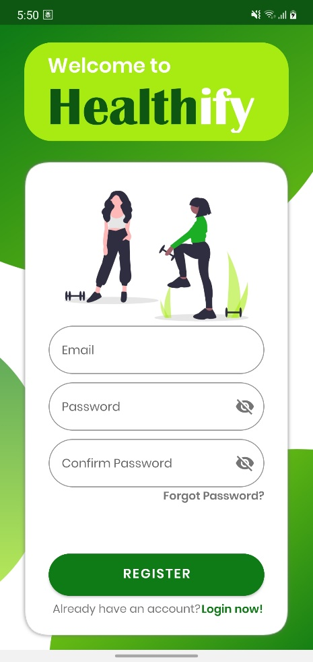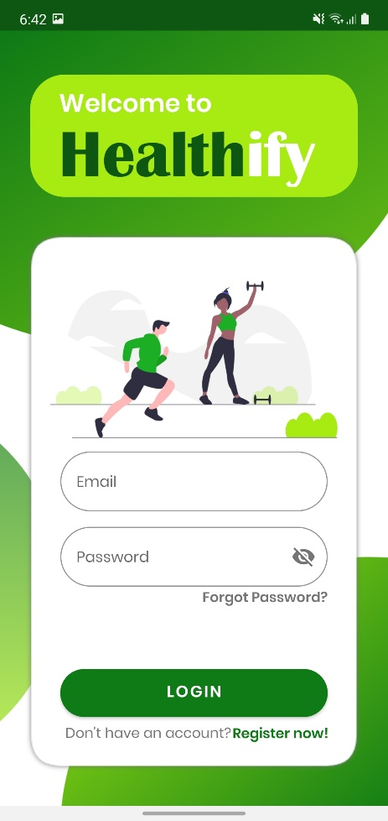

Figure : Register Screen

Figure : Login Screen

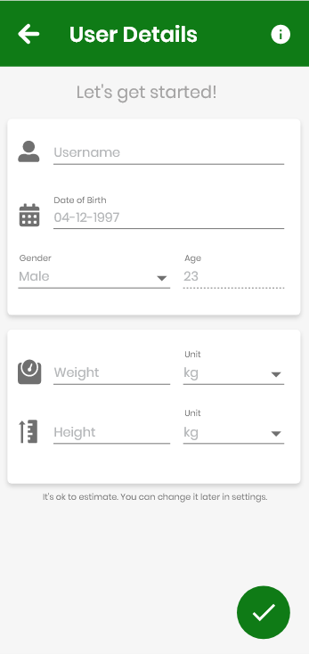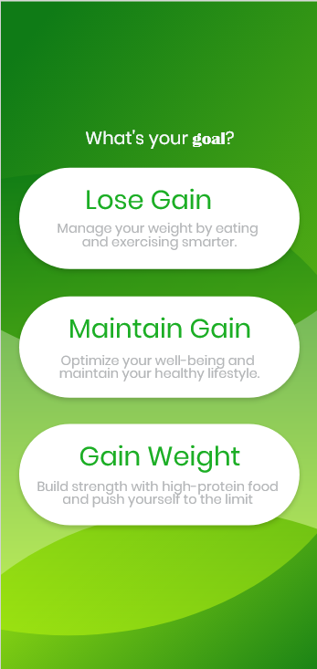

Figure : 'User Targets' Screen

Figure : BMI Test

#### Fitness Tracker

The users will also be able to log their daily physical activity through the proposed application. This will allow the application to track users’ progress/statistics and present them in forms of graphs or charts. Using this data, the app will give the user a visual representation of their progress, how much they have improved and how far they are to reach their goals. It will also allow the user to display their progress weekly or monthly, in addition, show a comparison graph of their progress from the previous week/month.

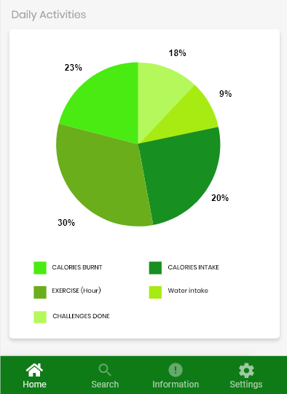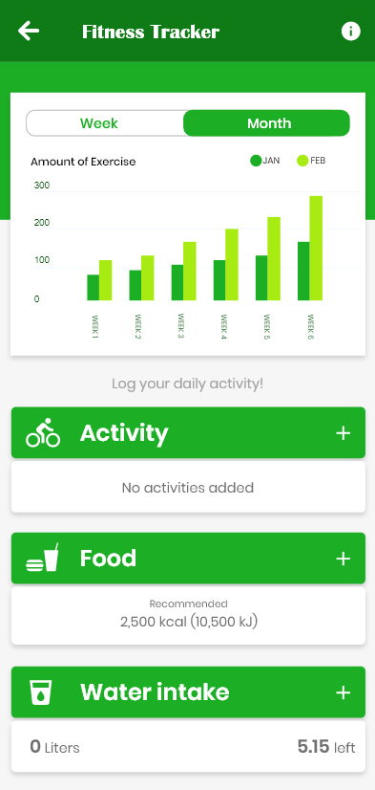

Figure : Fitness Tracker Screen (1)

Figure : Fitness Tracker Screen (2)

#### Sports and Exercise Encyclopaedia

The proposed application will have information regarding all sports to help promote exercise by giving helpful tips and advice. It will have a brief description of the sports and explain the benefits each sport will have on the body, how many calories players could burn on average, equipment you will require in-order to begin and the general costs you may need to think about (i.e., club membership etc). The application will also allow players to search for any local clubs or sport centres/facilities in their local arena or within a certain radius doing that sport. It will then display all the local clubs/facilities with the chosen radius, their address, contact information, and furthermore their location pinned on the map. This will be possible after the user provides the application their post code, which the application will use to filter the data and display the correct facilities. Aside from sport activities, the app will also contain other form of physical activities for those not interested in sports; for example, Hiking, Yoga and Running etc. In addition to all this, it will also recommend other applications dedicated to a certain sport or physical activity for those users who do not wish to join a club or go the facility due to busy schedules etc. For example, if a user wanted to do yoga, but did not wish to join a yoga club and wanted to do it at home, the proposed application will recommend the user some external application such as ‘Glo’ which is a mobile application dedicated to yoga and allows the user to practice at home. There will also be diagrams/illustrations provided for each exercise that can be performed at home, so the user’s do not injure themselves performing it incorrectly.

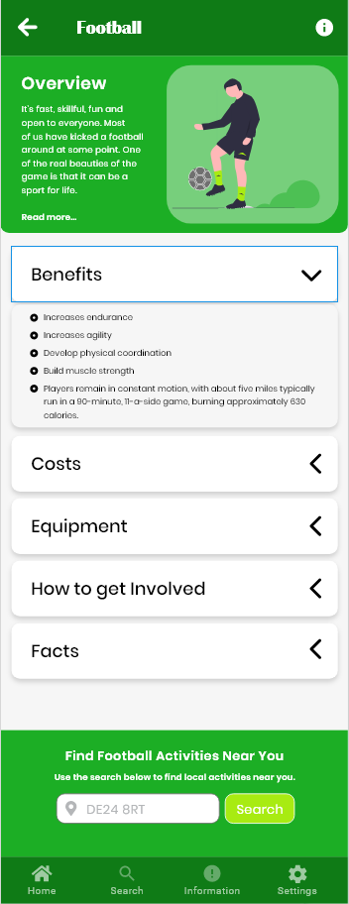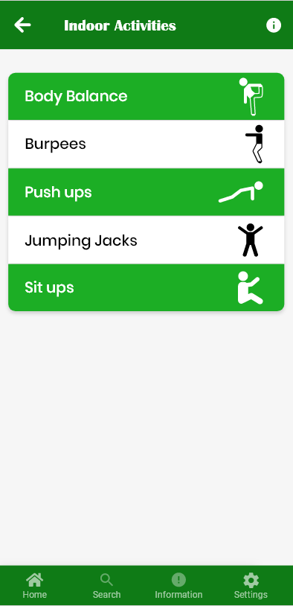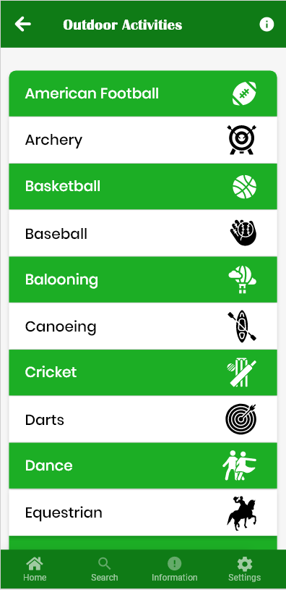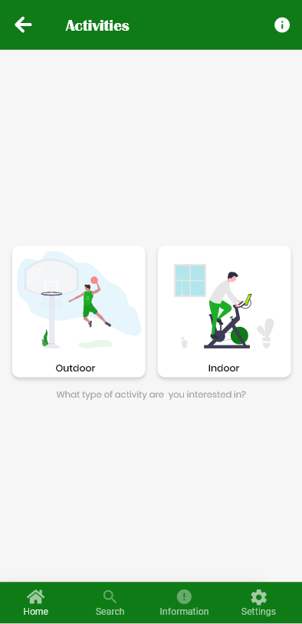

Figure : Activity Info

Figure : Outdoor Activities

Figure : Indoor Activities

Figure : Select Type of Activity

#### Daily Challenges

The proposed application will provide users daily challenges to help keep them motivated, which will earn them points when they complete them. At the end of each week, using the points, the users will be ranked depending on how many challenges they have completed. This will provide a competitive aspect which will motivate users more as they would want to be ranked higher than others allowing them to push themselves to gain as much points as they can weekly, resulting in them doing more exercise and staying healthy.

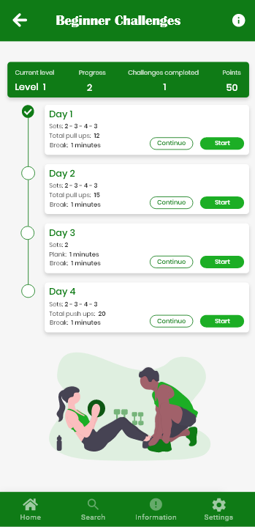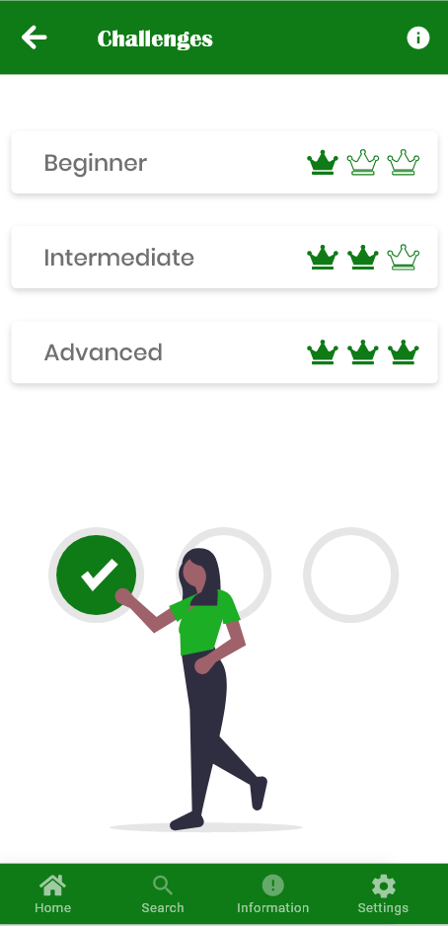

Figure : Beginner Challenges Screen

Figure : Daily Challenges Screen

IMPLEMENTATION or INVESTIGATION

Introduction

Here you give details of the development or investigation of the new material proposed in 'New Ideas'. This must be done in a business-like manner. The development of any software must follow a suitable analysis and design methodology. There are CASE tools available to you for some methodologies, others will have to be a 'paper' design. An investigation must also follow a suitable methodology and use appropriate techniques and tools.

Software-based projects, requiring the production of a software solution for a set of requirements, should demonstrate that the software development has undergone appropriate analysis, design, project management, structured programming and testing. Research-based projects, requiring an investigation of a research question or client’s requirements, or being used to test a hypothesis, should demonstrate that the investigation has been properly conducted, is based on scientific principles and uses appropriate tools, techniques and standards. An investigation must produce a technical outcome from some development (software or hardware (e.g. networks, displays)) or testing (e.g. of system/network performance, system security, HCI/usability analysis). Sometimes a software prototype or a testing framework will be produced for the evaluation or testing of the research or hypothesis. Work based purely on literature review is not acceptable.

Some projects aim to provide software for general use as their final product and these must include relevant aspects of HCI (Human Computer Interaction) and address such features of usability such as 'user friendliness' and most likely employ GUI (graphical user interface) standards such as Windows.

In any case, students often ask what should go in this chapter, how to describe what they have done, what is relevant, how much of existing work to include, what to include from what they have done, etc. The simplest and surest way is to refer to your diary of the work you have done and report on it in chronological order.

The complete requirements analysis, problem analysis & design of software must be done rigorously and included in full in an appendix. Avoid cross-referencing it too often, thus causing the reader to keep flicking pages back and forth, rather reproduce sections that you wish to draw the reader's attention to. That is, highlight the parts that you found particularly difficult to implement and feel rather proud of having solved. Do not include lengthy descriptions of standard techniques or methodologies, simply state that 'such-and-such was designed using such-and-such technique (give a reference, not just 'SSADM' but 'SSADM [James 1996]' where the reference is a standard text on the technique!)' and highlight where you found shortcomings in the technique that didn't quite cope with your particular problem. Highlight exceptions to the standard.



RESULTS / DISCUSSION

Introduction

The technique developed in your project is supposed to show improvement on techniques previously available. Therefore it may be necessary to spend time investigating whether this is true. Perhaps you need to set up some sort of quantitative test and do a little statistical analysis to confirm the improvement. This chapter will provide evidence, from the tests that you carry out, of the outcomes of your project.

Explain the success and limitations of your work and show how this relates to the aims and objectives set out in the introduction.



CONCLUSIONS / FUTURE WORK

## Conclusions

Whatever it was that your results showed should be summarised here. Your project or may or may not have achieved all that you set out to at the start.

This is your opportunity to conclude whether the project was a ‘success’ and how it might have been tackled differently in hindsight.

## Future work

In either case there should be some reference to future work, either to forward and expand on the successful outcome or to test ways of overcoming the shortfall in your ideas that didn't work out quite as expected but there should be something that shows you can see further implications of what you have achieved.

## Legal, Social, Ethical and Professional Issues

This section should include a discussion of the four LESPIs and the way in which you project has/will/could impact on each.

## Synoptic Reflections

This section will comprise of a reflection on the project in relation to employment aspirations and the skills that you have developed towards this through engagement with the project.

ReferenceS

Vogt, C. 1999. Creating Long Documents using Microsoft Word. Published on the Web at the Nottingham Trent University.

**Note:** References are a list that includes the essential bibliographical details for each item to which you have referred in the body of your paper. It should ONLY include items to which you have made direct reference. A direct reference is where you have quoted/reproduced text or diagrams from another author or mentioned/referred to the work of another author in your report. That is quoted directly what they have said about something or mentioned their views or conclusions in your report. For details of citation and references see the information in the Project Guide.

A Bibliography is a list of published materials that you have read or consulted for general information in the preparation of your work, concerning the subject of your Project, but have not made any direct reference to in your report i.e. 'background reading'.

You should always provide a Reference List. **A Bibliography is optional but when provided it should include all items in your Reference List as well as any additional items consulted in preparation of your work.**

Bibliography

(Some of these are references) – FIX THEM LATER!

nhs.co.uk. (2012). Lack of exercise as 'deadly' as smoking. [Online]. [21 October 2019]. Available from: https://www.nhs.uk/news/lifestyle-and-exercise/lack-of-exercise-as-deadly-as-smoking/

Davis, K. (n.d.). The Effects of Lack of Exercise on the Body | Livestrong.com. [online] LIVESTRONG.COM. Available at: https://www.livestrong.com/article/351679-the-effects-of-lack-of-exercise-on-the-body/ [Accessed 28 Oct. 2019].

National health service, N.H.S. 2019. Statistics on Obesity, Physical Activity and Diet, England, 2019. [Online]. [4 December 2019]. Available from: https://digital.nhs.uk/data-and-information/publications/statistical/statistics-on-obesity-physical-activity-and-diet/statistics-on-obesity-physical-activity-and-diet-england-2019/introduction

Robert, B.2017. Obesity: Health Risks Associated with Obesity. [Online]. [1 February 2020]. Available from: https://www.onhealth.com/content/1/health_risks_associated_with_obesity

National health service, N.H.S. 2018. Obesity: Health Risks Associated with Obesity. [Online]. [2 February 2020]. Available from: https://www.nhs.uk/conditions/gallstones/

Cancer research UK. 2018. Does obesity cause cancer?. [Online]. [3 February 2020]. Available from: https://www.cancerresearchuk.org/about-cancer/causes-of-cancer/obesity-weight-and-cancer/does-obesity-cause-cancer

Centers for disease control and prevention. 2019. Strategies to Prevent Obesity. [Online]. [15 February 2020]. Available from: https://www.cdc.gov/obesity/strategies/index.html

National health service, N.H.S. 2019. Treatment. [Online]. [7 February 2020]. Available from: https://www.nhs.uk/conditions/obesity/treatment/

National health service, N.H.S. 2018. Benefits of exercise. [Online]. [7 February 2020]. Available from: https://www.nhs.uk/live-well/exercise/exercise-health-benefits/

Awais dar, A.D. 2018. 8 Ways Technology is Improving the HealthCare. [Online]. [7 February 2020]. Available from: https://thriveglobal.com/stories/8-ways-technology-is-improving-the-healthcare/

Positive gaming. c2020. The Benefits of Exergaming. [Online]. [8 February 2020]. Available from: http://www.positivegaming.com/positivegaming/benefits/exergaming-benefits

Ground report. 2007. DANCE DANCE REVOLUTION AND ASSOCIATED HEALTH BENEFITS. [Online]. [8 February 2020]. Available from: https://www.groundreport.com/dance-dance-revolution-and-associated-health-benefits/

Human kinetic . c2020. TECHNOLOGY CAN BOOST PHYSICAL ACTIVITY PROMOTIO. [Online]. [10 February 2020]. Available from: https://us.humankinetics.com/blogs/excerpt/technology-can-boost-physical-activity-promotion

Christina woodger, C.W. 2018. Five ways tech can help you get fit and be more active in 2020 Read more: https://wwwwhichcouk/news/2018/12/five-ways-tech-can-help-you-get-fit-in-2020/ - Which?. [Online]. [10 February 2020]. Available from: https://www.which.co.uk/news/2018/12/five-ways-tech-can-help-you-get-fit-in-2020/

Lauren pufpaf, L.P. 2019. The Fitness App Ecosystem in 2019: Specializing in Specialization. [Online]. [10 February 2020]. Available from: http://blog.feed.fm/the-fitness-app-ecosystem-in-2019-specializing-in-specialization

Jill duffy, J.D. 2019. MyFitnessPal. [Online]. [14 February 2020]. Available from: https://uk.pcmag.com/iphone-apps/5599/myfitnesspal

Webwise. c2019. Explained: What is Pokémon Go?. [Online]. [14 February 2020]. Available from: https://www.webwise.ie/parents/pokemon-go/

Allegra frank. 2018. Pokémon: Let’s Go! co-op is fun, if you don’t mind a way easier game. [Online]. [14 February 2020]. Available from: https://www.polygon.com/2018/10/15/17965206/pokemon-lets-go-co-op-impressions-preview

Appendix A

The content of these will differ with the different types of project. Any design and analysis charts/diagrams will be included here in full. In projects where software has been developed there will be an appendix for this. Our departmental requirement is that a CD, DVD or USB memory stick of all source code is submitted to your project supervisor. The appendix contained in the report will refer to this CD, DVD, or USB memory stick, provide a directory style listing of the files submitted and instructions for rebuilding and running the software. This might be source code of programs written in high level languages (C, C++, etc) together with any pertinent files ('make' files, non-standard libraries, etc). Alternatively, or in addition, you can place some or all of the source code in the appendix. In any case the source code needed to reconstruct any software you have developed must be submitted in its entirety in the CD, DVD, or USB memory stick. (Any code that has been used from a third party should reference the original developer).

Hardware designs will require schematics/circuit diagrams, PCB layouts, simulation tests and pin outs.

Most projects will require some form of user documentation to explain how to use the software/hardware produced. A researcher following up the work may wish to utilise the work of the original author and an appendix laying out the format of input files and how to interpret the output is required.